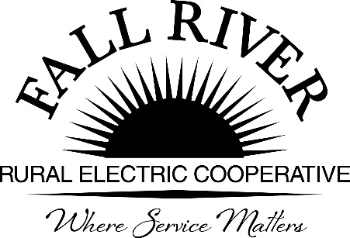**AGENDA**

**Monday, October 16th, 2023**

**Fall River Rural Electric Cooperative, Inc.**

**Board Meeting**

**2024 Proposed Operating and Capital Budgets**

Ashton Boardroom

Start Time: 10:00 a.m. *Items that need action taken. Stop Time: 12:00 p.m.

10:00 a.m. 1. Preliminary

Call to Order

10:02 a.m. 2. **\***Approval of Agenda

10:03 a.m. 3. 2024 Strategic Objectives Included in the Proposed Budget

1. Vision and Strategic Objectives **(Included in Packet)**
2. 2024 Highlights of Assumptions and Significant Budget Items **(Included in Packet)**

10:40 a.m. 4. **\***Review Proposed 2024 Operating Budget **(Included in Packet)**

1. 2024 Operating Budget Summary **(Included in Packet)**
2. Budget Variance Analysis **(Included in Packet)**
3. Labor and Overhead Analysis **(Included in Packet)**
4. Trended Operating Statement **(Included in Packet)**

11:10 a.m. 5. **\***Review Proposed 2024 Capital Budget **(Included in Packet)**

11:35 a.m. 6. 2024 General & Early Retirement of Patronage Capital

1. *General Patronage Capital Retirement – **(Included in Packet)**
2. *2024 Proposed Early Retirement Budget **(Included in Packet)**

11:57 a.m. 7. * Proposals for Annual Audit and Summary **(Included in Packet)**

1. Summary of Audit Proposals **(Included in Packet)**
2. DeCoria & Co. Audit Proposal & Engagement Letter **(Included in Packet)**
3. Poston Denney & Kilpack Audit Proposal **(Included in Packet)**

11:57 a.m. 8. Preliminary Planning for January Pre-Audit Call - Finance Committee

Noon 9. Adjournment