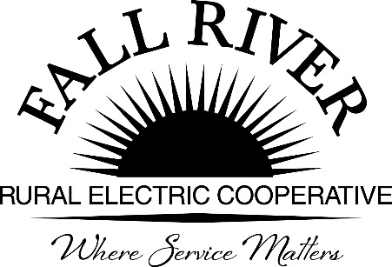
AGENDA

Monday, October 18th, 2021

Fall River Rural Electric Cooperative, Inc.
Board Meeting
2022 Proposed Operating and Capital Budgets

Ashton Boardroom

Start Time: 10:00 a.m. *Items that need action taken. Stop Time: 12:00 p.m.

10:00 a.m. 1. Preliminary
Call to Order

10:02 a.m. 2. *Approval of Agenda

10:03 a.m. 3. 2022 Strategic Objectives Included in the Proposed Budget
- Vision and Strategic Objectives (Included in Packet)
- Highlights of Assumptions and Significant Budget Items (Included in Packet)

10:40 a.m. 4. *Ten Year Financial Forecast (Included in Packet)

10:40 a.m. 5. *Review Proposed 2022 Operating Budget (Included in Packet)

11:10 a.m. 6. *Review Proposed 2022 Capital Budget (Included in Packet)

11:35 a.m. 7. 2022 General &Early Retirement of Patronage Capital
- *General Patronage Capital Retirement – 10 yr. Rolling Average (Included in Packet)
- *2022 Proposed Early Retirement Budget (Included in Packet)

11:57 a.m. 8. Preliminary Planning for January Pre-Audit Call - Finance Committee

Noon 9. Adjournment

