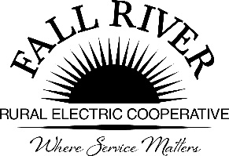
AGENDA
Monday, August 23, 2021
Fall River Rural Electric Cooperative, Inc.
Administrative Board Committee Meeting
Click on blue box for link

Start Time: 9:00 a.m. Stop Time: 10:00 a.m.
*Items that need action taken.

Meeting will start prior to the Fall River Rural Electric Board Meeting

3:00 p.m. 1. Preliminary
Call to Order

3:05 p.m. 2. *Approval of Agenda

3:10 p.m. 3. *Approval of Minutes April 26, 2021 (Included in Packet)

3:15 p.m. 4. Review Scholarship Process:
- Review Current Application Form
- High School Scholarships (Included in Packet)
- At Large Scholarships (Included in Packet)
- Helping Hands – Discuss Essay Needs (Included in Packet)
- Lineman Scholarship (Included in Packet)
- Review Essay Instructions (Included in Packet)
- Language to allow High School, At Large, and Helping Hands to accommodate technical/trade school programs (Included in Packet)
- Do we require letters of reference? If required, how many and guidance to applicants? If so, do they factor into our ranking process/extracurricular?
- Discuss if there is a need to review or handle Fall River Employees children differently.

5. Youth Ambassador/ Junior Board Member Program (Included in Packet)

4:00 p.m. 6. Adjourn – Next meeting is scheduled for at 9:00 a.m.
Members:
Chairperson - Jeff Keay, Doug Schmier, Georg Behrens, Jodi Stiehl, Anna Lindstedt, & Jay Hanson

